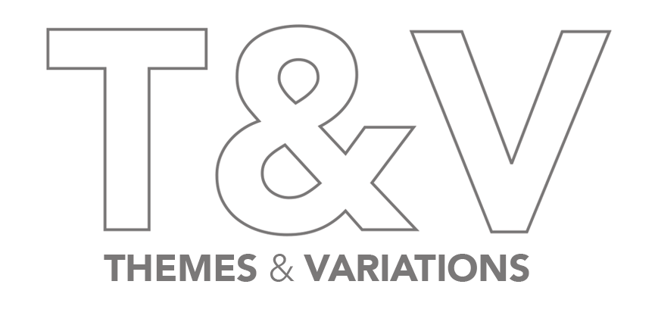

**GALERIE56 PRESENTS *ALL THE WORLD’S A STAGE***

**A Dynamic Exhibition of Avant-Garde Modern and Contemporary Design**

**Co-Curated with Themes & Variations**

**Gallery Hours:** Monday to Friday, 10AM–6PM

**Press Preview:** Thursday, November 6, 10AM–6PM

**Opening Reception:** Friday, November 7, 6PM–8PM

**(New York, NY–October 6, 2025)** Galerie56 is proud to announce an exciting collaboration with London’s pioneering gallery **Themes & Variations** for itsfifteenth selling exhibition. Opening on **November 7**, ***All The World’s A Stage***offers a fresh perspective on avant-garde modern and contemporary design, featuring **early works by Tom Dixon** and **André Dubreuil** alongside **new sculptural artworks** by **Benedetta Ubaldini** and **Anna Barlow** among others.

The exhibition marks the first collaboration between the two galleries and its founders, **Lee F. Mindel, FAIA**, and **Liliane Fawcett**, who have a shared reverence for the decorative arts in all of its forms and the ongoing dialogue between historic and contemporary design. With ***All The World’s A Stage***,the importance of avant-garde sensibilities is brought to the foreground while highlighting its impact and enduring influence on designers and artists to this day.

"My respect and admiration for Liliane began some 40 years ago when we met at the opening of her trailblazing London gallery, which became the center of innovative design through her championing of burgeoning talents and eccentric aesthetics that are now firmly situated in the canon of international design,” notes **Lee F. Mindel, FAIA, founder of Galerie56**. “It's an honor to be collaborating with her in this way for the first time."

The works selected for ***All the World’s A Stage*** span time periods and countries of origin but all share a visual language defined by the experimental and theatrical nature of the avant-garde style. There are a significant number of pieces from the **Creative Salvage movement**, which was founded by Tom Dixon, Nick Jones, Mark Brazier-Jones, and the late André Dubreuil the same year that Fawcett first set up her London-based gallery. As an **early patron of Tom Dixon** and the **first gallery to exhibit his work**, Themes & Variations brings notable metal works spanning his entire career from ***Fish Pan Chair*** (one of his earliest works, crafted from found scrap metal) and ***Pylon Chair***(originally made in Dixon’s metal workshop in the early 1990s and designed to be the world’s lightest metal chair) to more recent masks made from welded salvage metal.

The exhibition also features **early works by André Dubrei**l including ***Desk and Chair***,which was first exhibited at Themes & Variations in his first solo exhibition in 1986; the impressive and rare ***Messanger* Console** **by Mark Brazier-Jones**; themonumental ***Neptune*** wall sculpture by **Anthony Redmile**; sculptural jewelry by **Eileen Coyne**; hyper-realistic ceramic sculptures by **Anna Barlow**; and large-scale wire sculptures by **Benedetta Mori Ubaldini.**

"Expression over Function - I believe that each piece in this exhibition exudes emotion,” states **Liliane Fawcett, owner of Themes & Variations**. “The story they tell through their unconventional visual tension carries a theatrical sensitivity: a desk, a chair, a mirror stages you in a performance where its form is the drama. In that sense they open the door to a more holistic approach to design."

***All the World’s A Stage*** features the work of Tom Dixon, André Dubreuil, Mark Brazier-Jones, Eileen Coyne, Anna Barlow, Deborah Thomas, Piero Fornasetti, Tony Duquette, Danny Lane, Jenny Martin, Anthony Redmile, and Benedetta Mori Ubaldini. The exhibition is on view from **November 7 - January 8, 2025** at Galerie56 located at 240 Church Street, New York, NY.

**About Galerie56**Founded by Lee F. Mindel, FAIA, and designed by his award-winning architectural firm SheltonMindel in 2021, Galerie56 is at the center of Manhattan's TriBeCa neighborhood, nestled into the street-level base of the iconic 56 Leonard - designed by acclaimed architects Herzog & De Meuron, and adjacent to the new landmark sculpture by Anish Kapoor. It is conceived as a civic gesture meant to extend the seemingly private world of art and architecture into the context of the city. It reflects deep American values of openness, transparency, and desire to welcome all international cultures to be part of a democratic discourse accessible to all. Through establishing a dialogue with Anish Kapoor's sculpture, the space not only acts as a physical node on Church Street but also as a larger metaphorical node within the vast network of artists around the world. The interior massing of the gallery space works in close synchronization with that of the form of the building - a deconstructed interpretation of its pronounced volumes by translating them into a series of intersecting planes within the space. The space establishes a dialogue with other vivid nodes like the Empire State Building and One World Trade Center, through thoughtful gestures such as theme-lighting during important civic events. The gallery serves as a beacon for the cultural ethos of the city.  
  
Galerie56 collaborates with globally significant partners including Galerie Downtown, Dansk Mobelkunst, Jacques Lacoste, Jackson Design, Sarah Myerscough Gallery, Southern Guild, and more. [galerie56.com](http://galerie56.com) / [@galerie56_official](https://www.instagram.com/galerie56_official/)

**About Themes & Variations**

Since its opening in 1984 in Notting Hill, London, Themes & Variations has been recognised as a leading specialist in Post-War and Contemporary Design. The selection of works reflects a passionate commitment to offering an exceptional and unexpected complement of important vintage and contemporary furniture, lighting, glass and ceramics, and fine and graphic arts. Themes & Variations has a reputation for anticipating new trends in a constantly evolving market through its program of exciting exhibitions and *Le Monde* has described it as "...a mythical, astonishing gallery."

Its inaugural exhibition presented the work of a very young Tom Dixon, and 40 years later, Themes & Variations celebrated its four decades with a retrospective of Dixon's design - a full circle to mark the closing of the gallery's physical space to focus on pursuing projects and exhibitions in diverse venues. "If London is having a love affair with European Contemporary and Post-War Design, Fawcett was the matchmaker," according to Max Fraser, *The London Design Guide.*

# # #

**Media Contact:**

Novità PR

Kristin Coleman

kristin@novitapr.com

(347) 728-3068